SUPPORT THE DREAM ACT
Many undocumented students find colleges and universities doors closed to them because of their immigration status after graduation. These are longtime residents of this country who have grown up and have made the United States their home. They have dreams of becoming professionals in their communities like lawyers, doctors, etc., and have the grades and 4.0GPAs to help them, but because of their immigration status, they are hardly encouraged and have little resources to continue a higher education. Thus, many students are forced to abandon their dreams and hopes of a career. How can we throw away such talented and gifted students?
By supporting student legalization, we are investing in communities that would eventually benefit from the careers that these students are pursuing. Our communities cannot afford to be ignoring these students anymore!

Take Action:
Download the DREAM Act petition from CHIRLA:
English: http://www.chirla.org/pdf/BushPetition_En.pdf
Spanish:http://www.chirla.org/pdf/BushPetition_Sp.pdf
sign and send back to us:
National Immigrant Solidarity Network, C/O Lee Siu Hin
1013 Mission St. #6, South Pasadena CA 91030

By collecting 65,000 petitions, one for every undocumented student that graduates every year, we will be one step closer to getting the DREAM Campaign passed this year!

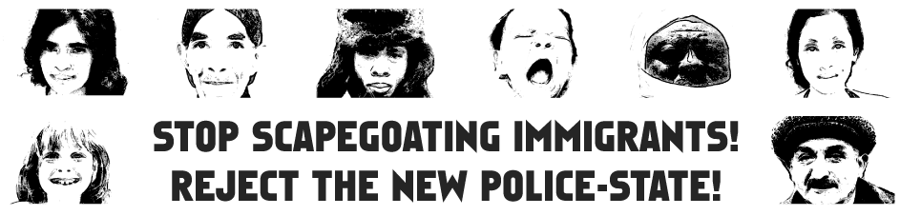
To learn how you can participate at the ISN projects, and endorse the ISN,
please visit our webpage: http://www.actionla.org/ISN/
and write to us by e-mail: ISN@ActionLA.org

Please subscribe to our daily-news litserv, send e-mail to:
isn-subscribe@lists.riseup.net
Or join our ISN monthly Action Alert! listserv, go to webpage
http://www.actionla.org/cgi-bin/mojo/mojo.cgi?f=list&l=isn

National Immigrant Solidarity Network
No Immigrant Bashing!
Support Immigrant Rights!

National Action Alerts and Immigrant Support Network

from the leading immigrant rights organizations,

human rights groups and labor organizations

for local activists

fight against special registration, the clear act, sevis, patriot act ii and any other anti-immigrants & anti-foreign students policies! yes on dream act and the legalization of undocumented immigrants!

The National Immigrant Solidarity Network (ISN) is a coalition of immigrant rights, labor, human rights, religious and student activist organizations from across the country. We work with leading immigrant rights groups: ACLU, AILA, CAIR, MPAC, SEIU, NIF & AFSC. In solidarity with their campaigns, and distribute their immigrant-worker related information and alerts, to our member organizations.

From legislative letter-writing campaigns to speaker bureaus and educational materials, ISN will keep your local network in touch and ready to join the critical immigrant-worker campaigns that are moving toward Justice for all!

Web: www.ActionLA.org/ISN/
Tel: (213)413-1778
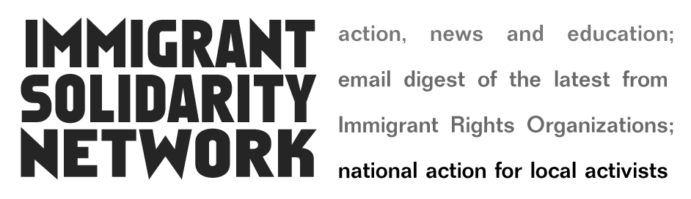

National Immigrant Solidarity Network: Our Vision

On 2003, ActionLA and several other national human rights organizations, such as United Students Against Sweatshops (USAS) and Latin American Solidarity Coalition (LASC) had initiated a proposal for a national Immigrant Solidarity Network that will give local activists tools to act in solidarity with immigrants seeking human rights and justice in the U.S.

The network will support immigrants by amplifying advocacy work such as that of the ACLU, American Immigration Lawyers Association (AILA), National Immigration Forum, American Friends Service Committee (AFSC), AFL-CIO, United Farm Workers Union, National Network for Immigrants and Refugee Rights (NNIRR), and others who maintain campaigns to protect immigrants from threats such as CLEAR Act, Special Registration, SEVIS and PATRIOT Act II. And support DREAM Act and the legalization of undocumented immigrants.

The network will provide a monthly Action Agenda includes: E-mail Alert! Newsletter and National Action Phone Conference, created by representatives from activist networks working in Labor, Economic Justice, Human Rights, Peace and Civil Liberties movements. Using this email network as a hub, we hope to spread information out among many spokes across the country. The alert will be digest of the latest "click and send", phone and fax, post card and letter campaigns to defend and establish Human Rights in the U.S.


we demands!

OPPOSE THE CLEAR ACT - H.R. 2671
This bill requires state and local police to enforce federal, civil immigration laws.
Using local police to enforce federal immigration laws conflicts with their primary mission of fighting crime in our communities. Under CLEAR, Domestic violence, gang intimidation and drug activity will likely all increase because when immigrants begin to see local police as agents of the federal government, with the power to deport them or their family members, they are less likely to approach local law enforcement with tips on crimes or suspicious activity.

Take Action:
Write to Congress
Friends Committee on National Legislation
http://capwiz.com/fconl/issues/alert/?alertid=4014606

The National Immigration Forum
http://www.immigrationforum.org

THE CAMPAIGN AGAINST SEVIS
Student Exchange Visitor Information System (SEVIS) is a computer system for racial profiling that singles out and criminalizes approx. 584,000 international students in the U.S.
The USA PATRIOT Act and the Border Securities Act make it mandatory for universities to provide information on international students directly to the INS, the State Dept, the FBI, and other government agencies. Under the law, universities must enter confidential student information into the SEVIS (Student Exchange Visitor Information System) computer system.

NO TO THE FUTURE SPECIAL REGISTRATION
Although it’d declare “ended” by the Bush administration, according from the National Immigration Forum the special registration didn’t over and it can come back anytime the government wants to.
The "call-in" provisions of the INS Special Registration program require innocent immigrants to report to INS offices to “register”, only to find themselves subject to arbitrary arrest, detention, abuse and possible deportation.

