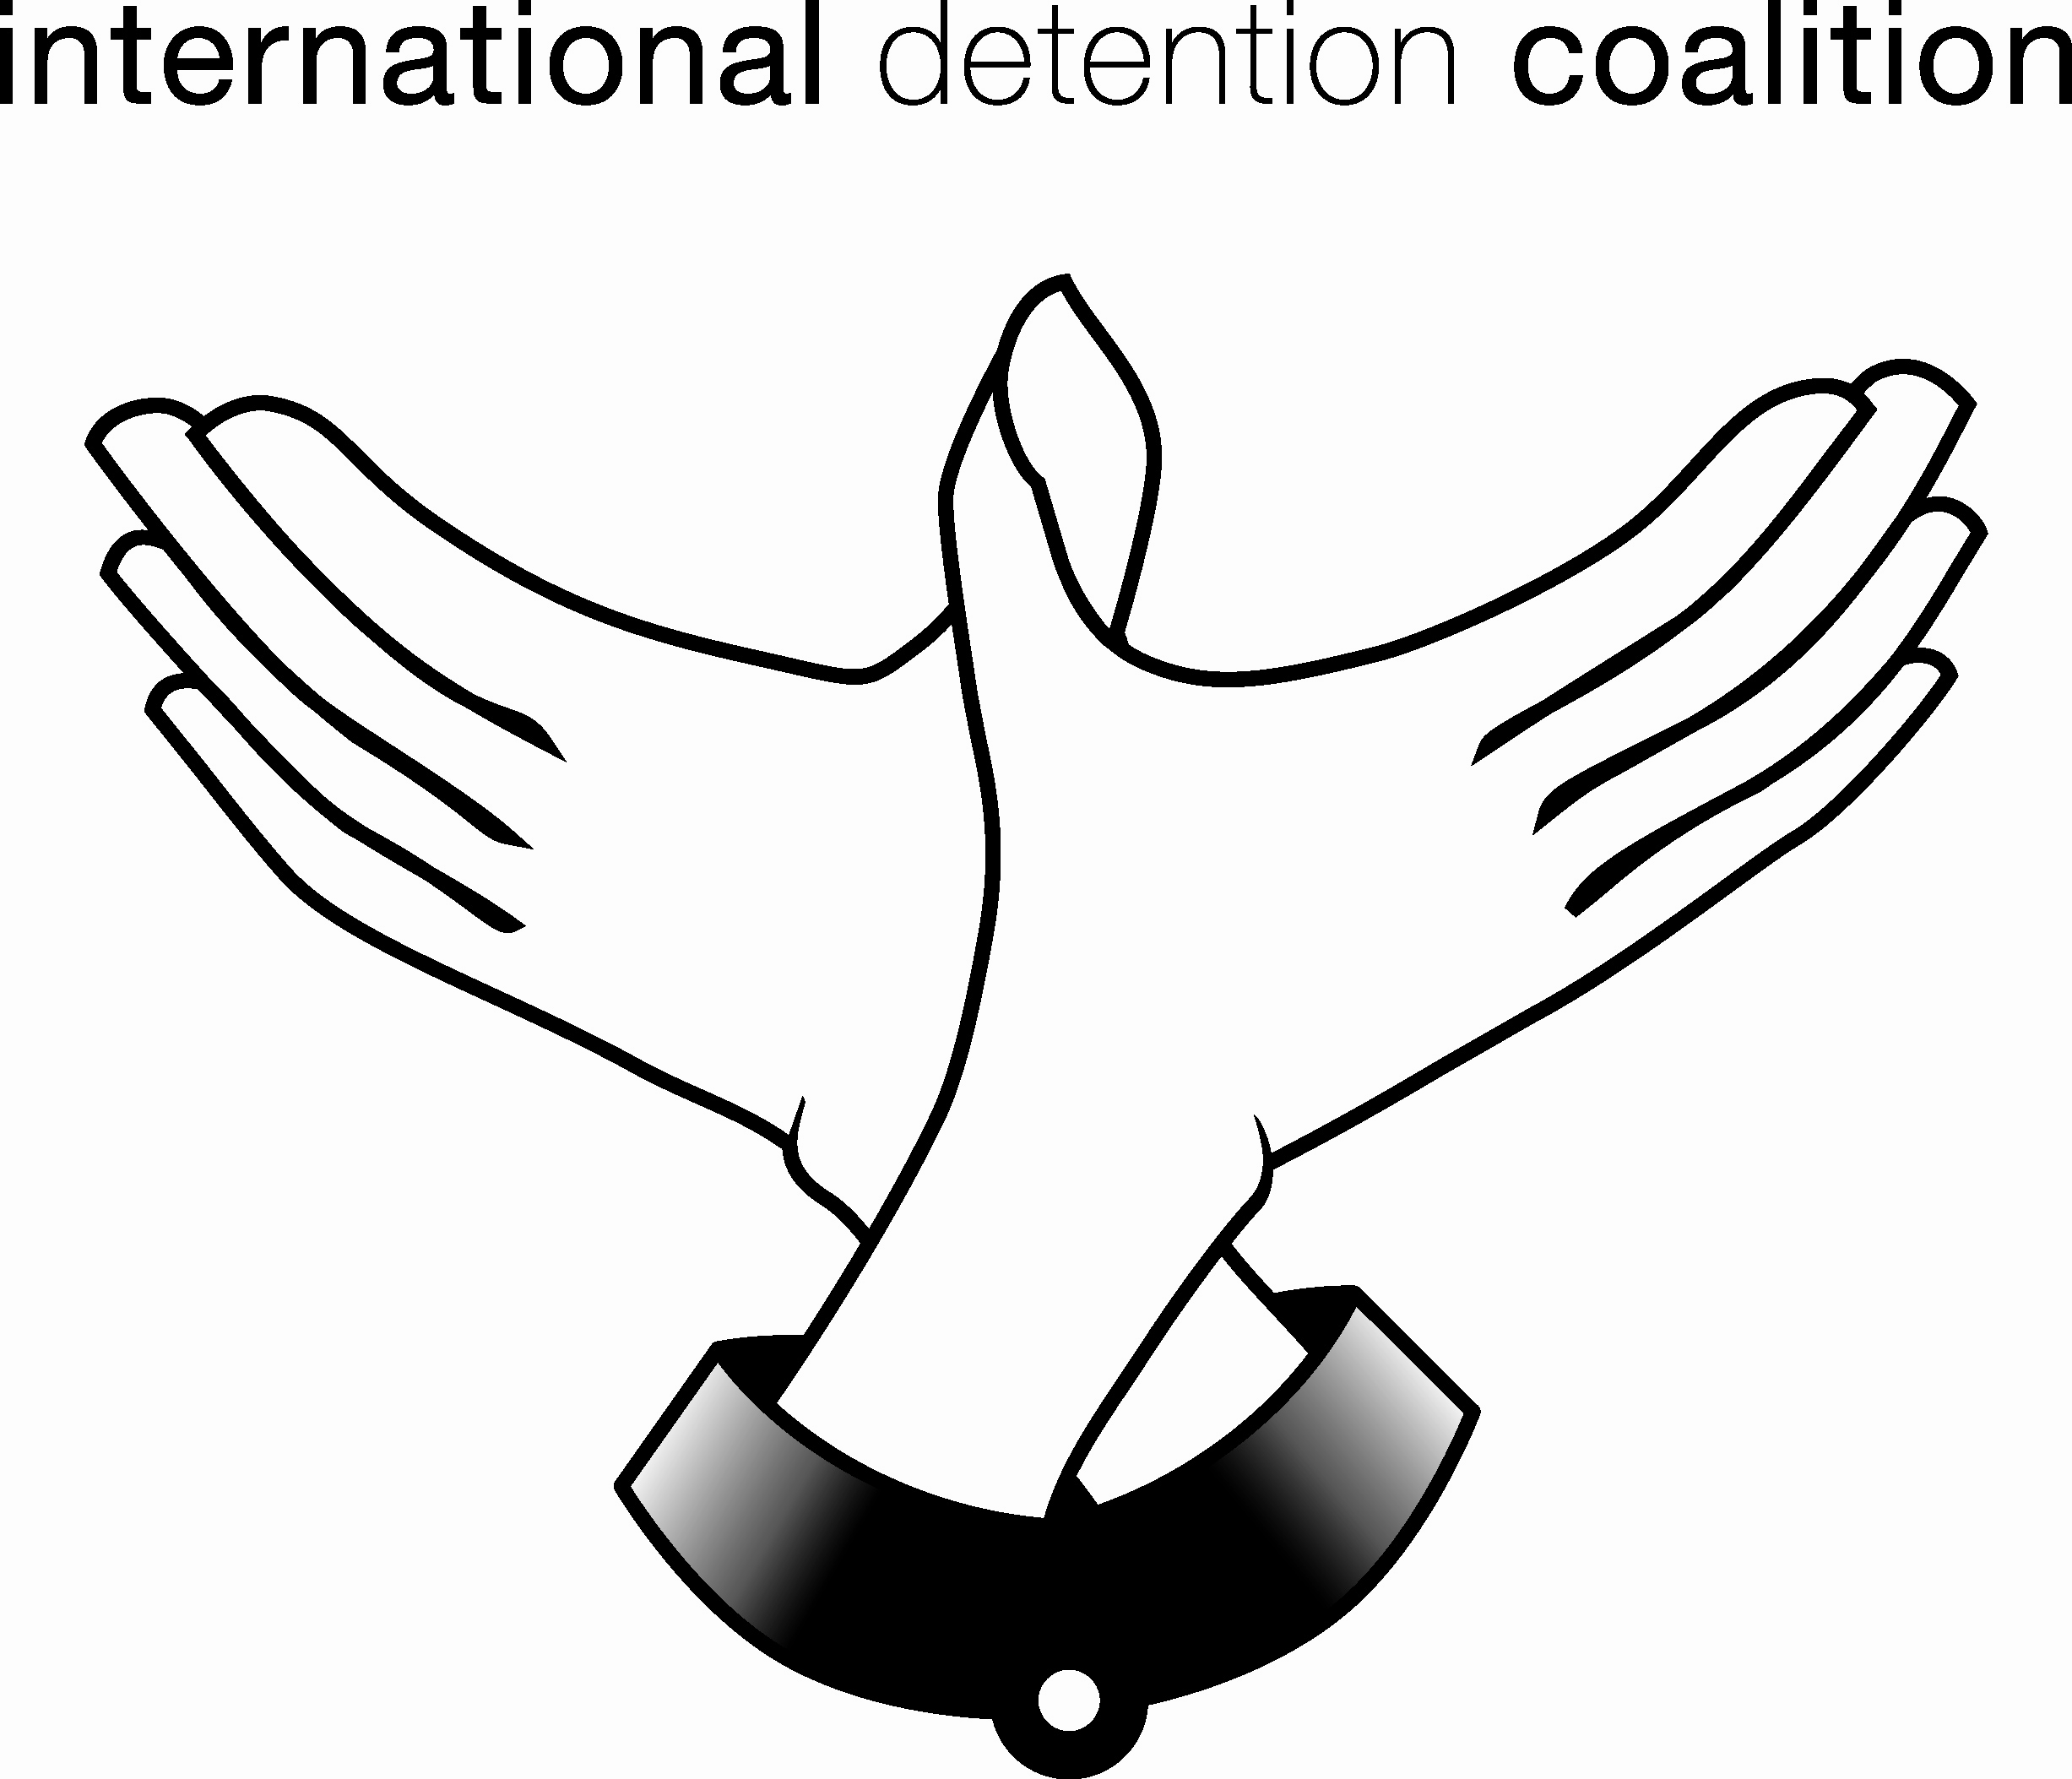

International Coalition on the Detention of Refugees, Asylum Seekers and Migrants (IDC)
www.idcoalition.org

Coordinators: Melanie Teff: melanieteff@idcoalition.org
Anna Gallagher: anna.gallagher@idcoalition.org

The International Coalition on Detention of Refugees, Asylum Seekers and Migrants is a coalition of non-governmental organizations, faith based groups, academics and individuals working around the world providing legal, social, medical and other services, carrying out research and reporting, and doing advocacy and policy work on behalf of refugees, migrants, and asylum seekers. These groups and individuals have come together to form the coalition in order to share information and to promote best practices on the use of detention vis-à-vis this population.

Why is there a need for an international coalition on detention of Refugees, Asylum Seekers and Migrants?
More and more governments around the world are using detention as a migration management tool. They are also cooperating bilaterally or multilaterally in attempts to restrict migration flows, sharing information and at times personnel in these efforts. NGOs and others working with detained and on migration related detention issues, therefore, should share resources and information in order to promote greater respect and protection for the human rights of refugees, asylum seekers and migrants. Detention policies and practices in one region affect other regions. Therefore, there is a need to tackle the global picture and assess and address the regional and international impact of government policies and practices.

What is the aim or mission of the International Coalition on Detention of Refugees, Asylum Seekers and Migrants?
The overall purpose of the coalition is to raise awareness of detention policies and practices and promote the use of international and regional human rights standards and principles as they relate the detention of refugees, asylum seekers and migrants.
The specific objectives of the coalition are:
• to prevent and/or limit the use of detention of asylum seekers, refugees and migrants;
• to advocate for alternatives to detention, and for the use of the least restrictive forms of detention;
• to promote greater protection of and respect for the human rights of those held in detention; and
• to promote the development and adoption of best practices in the use of detention.
The coalition plans to carry out its work on the above objectives through networking, advocacy, raising public awareness and through research and reporting on issues worldwide relating to the detention of refugees, asylum seekers and migrants.

What is the structure of the International Coalition?
There are over 100 members of the coalition in over 40 countries around the world. The Steering Committee of the coalition is comprised of representatives from Human Rights First, Human Rights Watch, Women’s Commission for Refugee Women and Children, Canadian Council for Refugees, Jesuit Refugee Service, Lutheran Immigration and Refugee Services, Amnesty International and the World Council of Churches and representatives from non-governmental organizations located in the following twelve regions:
• Australia/New Zealand
• Eastern Africa
• Southern Africa
• North Africa and the Middle East
• Central and Eastern Europe
• Western Europe
• South Asia
• Southeast Asia
• United States
• Canada
• Mexico and Central America
• South America and Caribbean

How can your group work with the coalition?

The regional IDC contacts for USA are: Detention Watch Network and Refugee Council/USA –
Andrea Black – DWN: ablack@detentionwatchnetwork.org
Angela Smith-Dieng – DWN: asmith-dieng@detentionwatchnetwork.org
Matt Wilch – RC/USA: MWilch@lirs.org

- Join the IDC and join in its advocacy work
- Send information about immigration detention in your area to the IDC, via your regional contacts, to be posted on IDC website and in IDC newsletter
- Visit IDC website and support its work
- Participate in the IDC campaign against immigration detention of children –
  - Raise the issue of immigration detention of children in press releases, eg. for World Refugee Day (20 June 2007) - and send copies to IDC
  - Organise an event around Universal Children’s Day (20 November 2007) to highlight IDC report on detention of children around the world (report to be available in November 2007)
  - Mobilise members to support campaign against immigration detention of children in Malaysia (IDC is awaiting details from Malaysian NGOs to confirm what support from overseas they will find most effective)
Some recent court decisions and legislative changes re children in immigration detention

UN Human Rights Committee (HRC) re Australia:

Baban v Australia, Communication No. 1014/2001, UN Doc. CCPR/C/78/D/1014/2001, decided 6 August 2003
Accompanied child held in detention nearly 2 years (until family escaped from detention centre)
Found violation of Article 9 of ICCPR (right to liberty and security of person)

Bakhtiyari v Australia, Communication No. 1069/2002,
UN Doc. CCPR/C/79/D/1069/2002, decided 29 October 2003
5 accompanied children held in detention for nearly 3 years; 2 children developed serious mental health problems in detention
Found violation of Article 9 of ICCPR (right to liberty and security of person) and Article 24 ICCPR (right to such measures of protection as required by status as a minor)

HRC’s reasoning for finding a violation of Article 24 of the ICCPR - “the children have suffered demonstrable, documented and on-going adverse effects of detention…in circumstances where that detention was arbitrary”

D and E v Australia, Communication No. 1050/2002, UN Doc. CCPR/C/87/D/1050/2002, decided 9 August 2006
2 accompanied children held in detention over 3 years
Found violation of Article 9 of ICCPR (right to liberty and security of person)

In above 3 cases, HRC proposed the imposition of reporting obligations, sureties or other conditions instead of detention.

Migration Amendment (Detention Arrangements) Act 2005 – children only to be detained as a last resort, move to community detention of children instead of closed detention centres

European Court of Human Rights re Belgium:

Mayeka and Mitunga v Belgium, 12 October 2006, Application No. 13178/03
5 year old unaccompanied child held in detention centre for 2 months in adult detention centre
Found violations of Article 3 ECHR (inhuman treatment), Article 8 ECHR (right to private life), Article 5 ECHR (right to liberty and security of the person)

European Court of Human Rights proposed placement in a specialised centre or with foster parents would have been appropriate.

South Africa:

The Centre for Child Law and Isabelle Ellis v Minister of Home Affairs and others, High Court of South Africa (Transvaal Provincial Division) Case no. 22866/2004, 8 September 2004
13 unaccompanied children held in adult detention centre in inadequate conditions
Held that deportation of non-national children should not take place until the children’s court determines on a case-by-case basis the best interests of each child, and that unaccompanied children should not be held in Lindela Repatriation Centre, but should be placed “in an appropriate place of care or place of safety”

Hungary:

Act II of 2007 – bans immigration detention of children

NB Changes in policy in UK for age determination of unaccompanied children – improved practice – social workers now have to carry out age assessments and not rely solely on child’s appearance, Home Office opinion or any documents available. A holistic approach is recommended which takes into account child’s demeanour, ability to interact with an adult, cultural background, social history and family composition, life experiences and educational history, as well as medical opinions.

Australia
Opinion polls in 2001-2002 showed that 77% of public agreed with the government’s policy of mandatory detention of asylum seekers.
By 2004, 75% believed that children should be released, and 61% did not support mandatory detention of refugees at all.
Major problems with asylum system in Australia still exist, but NGOs have won the following:
- laws preventing closed detention of children and their families
- vastly improved conditions of detention
- oversight of conditions and visa applications by the Ombudsman
- break in bi-partisan support for mandatory detention and temporary protection visas
- improvements in visa application process and in merits review procedures

Some strategies used by Australian NGOs

Positioned themselves as “middle Australians”

Re-cast the issue from immigration control to prevention of child abuse

Used images of real children – not just statistics – got children’s photos into media and onto posters

Built effective network – broad coalition of groups from different perspectives, eg. Australian Medical Association, religious organisations

Regular communication – teleconferences, internet, volunteers’ meetings

Reached out to general public, eg. events in shopping malls

Ordinary mums and dads visiting ordinary mums and dads in detention

Linked children in detention with other children – penfriends. Children then acted as youth ambassadors with politicians to talk about their own experiences in detention or about their friend in detention

Arranged a reporting coordinator inside each detention centre – to inform them when an incident inside the centre occurred – that they could then raise with the media

Obtained copies of contracts with private companies – for privately run detention centres – to know what the company was supposed to deliver. Developed a standard reporting sheet, and got detainees to take notes on breaches. Put pressure through media on conditions, but also on government by claiming breach of contract and a waste of taxpayers’ money

In Australia prisons have minimum standards set into law, but not detention centres – was a good lobbying point to say that convicted criminals get better treatment than asylum seeking children

Courted commercial media – provided them with good up-dated information on detainees (and to politicians etc.)

Co-option of hostile media

Used religious festivals for gift-drives – got good media coverage of this – particularly when they were refused access to deliver presents to refugee children at Christmas

