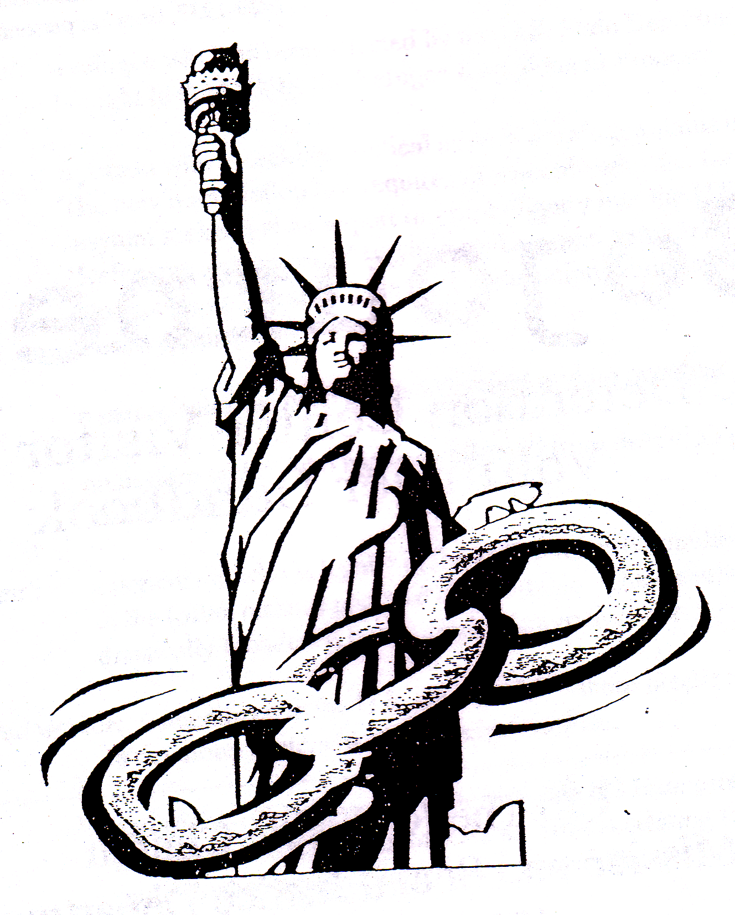
Sojourners

Detention Center Visitor Project

c/o The Riverside Church
Mission and Social Justice Department

490 Riverside Drive, New York, NY 10115
sojourners@theriversidechurchny.org
212-870-6808

Founded in 1999, the Sojourners Detention Center Visitor Project recruits, trains, transports, and mentors volunteer visitors to asylum seekers and other non-criminal non-citizens held at Elizabeth Detention Center, a windowless converted warehouse near Newark Airport in New Jersey.

We match visitors with detainees who do not have family or friends in the vicinity to visit them, for a sustained, one-to-one relationship. The purpose: to help break the isolation and boost the morale of detainees, who may be held for months, even years before a final determination on their request for asylum is made and they are released or deported.

Visitors must complete a 90-minute training, which covers basic terminology, detainees’ needs and concerns, the role of the volunteer visitor, such ground rules as confidentiality, good communication, procedures for entering the detention center, “ten steps for a good visit,” and FAQs (“Can I bring books/food/money for the person I visit?” “What if the person I visit doesn’t have a lawyer?” “The person I visit is being released – where can he/she stay?” “The person I visit is really sick – how can he/she get the needed help?”

A first-time visitor accompanies an experienced “mentor” visitor, after which he/she may be “matched” with a detainee he/she commits to visit at least twice a month. Most detainees wanting a visitor are referred by other detainees, and occasionally by detainees’ lawyers. Sojourners provides transport in Riverside Church-owned vehicles from both uptown and downtown Manhattan to Elizabeth Detention Center 10 times a month on a schedule (every Saturday morning, two Monday nights, two Wednesday nights). Management of notices and RSVPs for trips is handled by e-mail listserve.

Sojourners, whose volunteers come from all over New York City, works in collaboration with First Friends, whose volunteers are from New Jersey. David Fraccaro (812-454-2206) is Sojourners coordinator, and Carol Fouke-Mpoyo (646-258-8896) is Sojourners chair.

